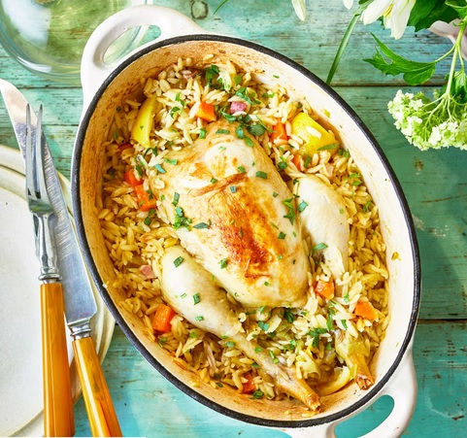
One-pot roast chicken with orzo
6 serving, 677 kcals, Fibre: 5g
- 2 Tbsp. olive oil
- 1 medium whole chicken, about 1.7kg
- 2 carrots, cut into 1.5cm pieces
- 1 leek, finely sliced
- 2 celery sticks, sliced
- 100 g pancetta lardons
- 1 lemon, cut into 6 wedges
- 1 tarragon sprig, plus extra leaves, chopped, to garnish
- 500 ml hot chicken stock
- 300g orzo pasta

- Preheat oven to 190°C (170°C fan) mark 5. Heat oil over medium-high heat in a casserole dish (that has a lid) that will hold the chicken with some space around it. Untruss the chicken and brown in the casserole, breast down, until breast is golden. Remove chicken to a board.
- Add carrots, leek, celery and pancetta to the dish and cook for 5min, until beginning to brown. Stir in lemon wedges, tarragon sprig and plenty of seasoning. Return chicken to the casserole dish, breast up. Pour in enough stock to come halfway up the sides of the chicken. Bring to the boil.
- Cover with the lid and cook in the oven for 50min. Carefully remove lid, scatter the orzo around the chicken, making sure the orzo is submerged in the stock, re-cover with the lid and return to the oven for 20min. Check the chicken is cooked; a meat thermometer inserted into the thickest part of the breast should read 72°C or higher.
- Carefully transfer the casserole dish to a board and leave to rest for 10min. Scatter over chopped tarragon and serve.

https://www.goodhousekeeping.com/uk/food/recipes/a34189357/roast-chicken-with-orzo/

