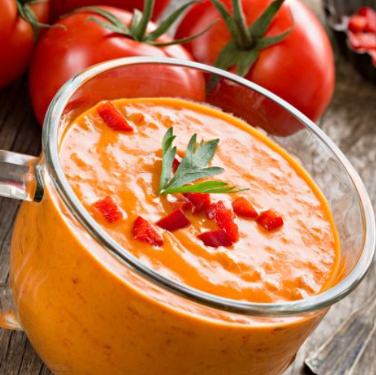
Mediterranean Soup (V)
Serves: 4. Kcal 122
- 1 onion, finely chopped
- 1 clove garlic, crushed
- 1 tbsp olive oil
- 1 bell pepper (red or yellow), diced
- 2 courgettes, diced
- 1 tsp paprika
- 1 tsp fresh rosemary, chopped
- 1 tsp Balsamic vinegar
- 400g can chopped or pureed tomatoes
- 1-litre vegetable stock made from 2 low salt stock cubes
- 1 tbsp Tomato puree
- 1 sprig fresh flat-leaf parsley (optional)
- Freshly ground pepper

- Heat the oil in a pan and gently cook the onion and garlic for 5 minutes without colouring.
- Set aside 1 tbsp of diced pepper then add the remainder of the pepper along with the courgettes, paprika, rosemary to the pan and cook for a few minutes.
- Add the balsamic vinegar, after 2 minutes add the tomatoes and stock and bring to the boil.
- Gently simmer until the vegetables are cooked through and tender, about 10 minutes.
- Finally, stir in the tomato paste. Either leave the soup as a rustic, chunky vegetable broth or use a handheld blender to blend until smooth.
- Season with fresh ground pepper and serve topped with the reserved diced pepper and a sprig of parsley.

https://www.heartuk.org.uk/tasty-recipes/recipe-detail/70-mediterranean-soup

