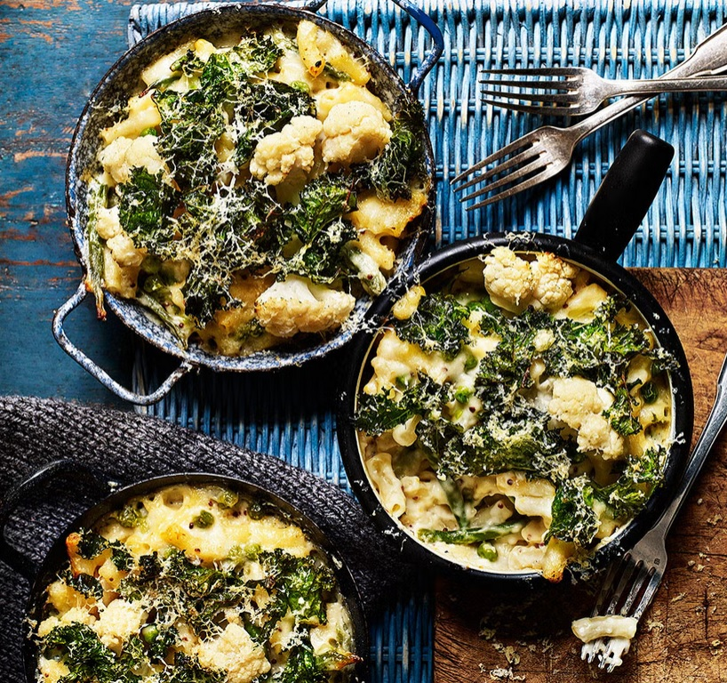
Macaroni Cheese & Greens (V)
4 serving, kcals 588, Fibre: 8 g
- 225g macaroni
- 200g green beans, trimmed and halved
- 250g cauliflower, cut into small florets
- 3 Tbsp. olive oil
- 50 g plain flour
- 600ml semi-skimmed milk
- 125g extra mature cheddar, finely grated
- 2 tsp. wholegrain mustard
- 100g frozen peas
- 50g kale, shredded

- Preheat the oven to 180°C (160°C fan) mark 4. Bring a large pan of lightly salted water to boil. Tip in pasta and cook for 5min, add green beans and continue cooking for 2min more, then tip in cauliflower, bring back to boil for a final 2min, until just cooked and still crunchy. Drain.
- Meanwhile, heat 2½ tbsp olive oil in a large saucepan and whisk in the flour. Cook for 2min, until beginning to smell toasty, then take off the heat. Gradually add the milk, whisking until smooth between each addition. Return pan to the heat and cook for 10min, stirring constantly, until thickened and smooth. Stir in 100g cheese and the mustard. Season.
- Add pasta, cooked vegetables and peas to the sauce, stir well. Spoon into 4 mini ovenproof baking dishes. Toss the kale with remaining oil and cheese and scatter over the pasta. Cook in the oven for 15-20min, until bubbling and golden.

https://www.goodhousekeeping.com/uk/food/recipes/a575081/macaroni-cheese-cauliflower-kale/

