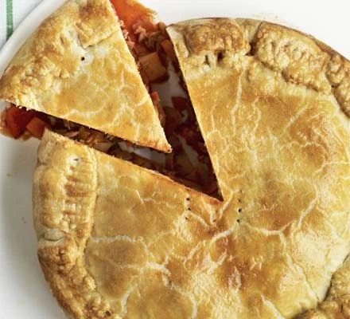
Tuna empanada pie
Serves 6, Kcals 537, Fibre 5g,
- 1 tbsp olive oil
- 1 onion, finely chopped
- 1 garlic clove, crushed
- 3-4 medium potatoes cubed
- 2 carrots, diced
- 2 red peppers, diced
- 1 tbsp smoked paprika
- 1 tsp each dried oregano and thyme
- 2 tbsp tomato purée
- 300ml vegetable stock
- 185g can tuna, in spring water, flaked
- 500g pack shortcrust pastry
- 1 egg, beaten

- Heat oven to 200C/180C fan/gas 6. Fry onion, garlic, potatoes and carrots in oil for 5 mins until softening. Add peppers, paprika, herbs and tomato purée, and cook for 5 mins.
- Add stock, bring to the boil, then simmer until stock is absorbed and vegetables are tender. Add the tuna.
- Roll a quarter of the pastry into a 22cm circle. Roll remaining pastry to line a 22cm loose-bottomed tin, allowing the pastry to come over the edges of the tin.
- Fill with the tuna mix and top with the pie lid. Brush the edges with egg then fold over the sides and press down with a fork to seal. Make two holes in the top, brush with egg and bake for 35-40 mins until golden brown. Leave to cool slightly, then serve.

