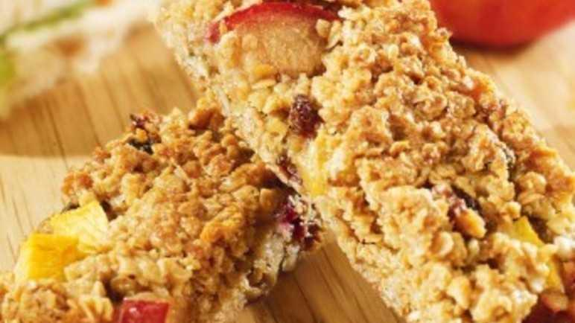
Plum and nectarine oat bars (V)
Serves 16, 225kcal, 2.2g fibre
- 140g light muscovado sugar
- 3 tbsp golden syrup
- 140g butter
- 250g rolled oats
- 50g raisins
- 50g walnut pieces, roughly chopped
- 50g mixed seeds
- 50g fresh plums, stoned and roughly chopped
- 50g fresh nectarines, stoned and roughly chopped

- Preheat the oven to 160°C/fan 140°C/gas mark 3. Gently heat the sugar, golden syrup and butter in a pan until melted.
- Add the oats, raisins, walnuts and seeds to the pan until coated in the butter. Spoon half the mixture into a 23 x 23cm baking tin.
- Scatter over the plums and nectarines, then top with the remaining oat mixture. Pack the mixture down well and smooth with the back of a metal spoon. Bake in the oven for 35 minutes, or until dark-golden. Leave to cool completely before cutting into 16 bars with a sharp knife.

https://www.sainsburys.co.uk/gol-ui/recipes/plum-and-nectarine-oat-bars

