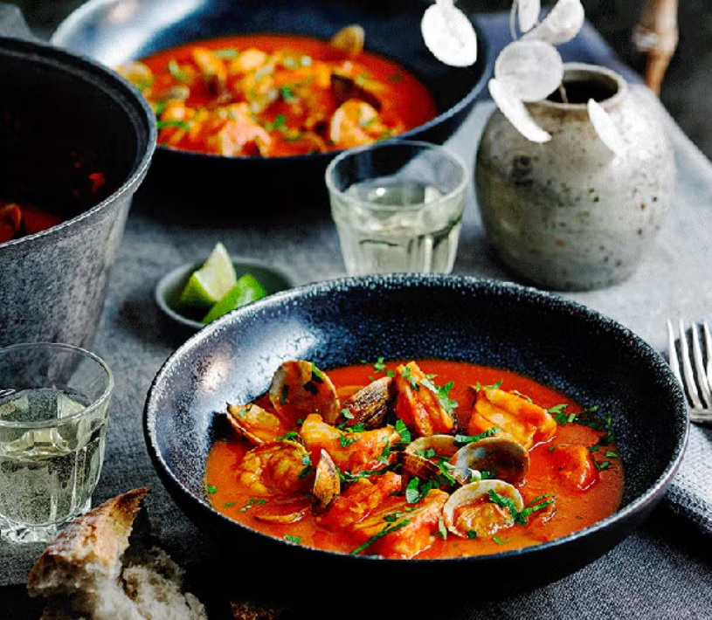
Portuguese-inspired fish stew
6 serving, 231 kcals, Fibre: 3 g
- 1 tsp. rapeseed oil
- 1 onion, sliced
- 2 roasted red peppers, from a jar, drained and roughly diced
- 3 garlic cloves, finely sliced
- 1 tsp. grated fresh root ginger
- 1 tsp. sweet smoked paprika
- 1/4 tsp. cayenne pepper
- 200 ml white wine
- 2 x 400 g tins chopped tomatoes
- 1/2 tsp. caster sugar
- 2 fresh bay leaves
- Pinch saffron
- 500 g clams
- 375 g cod loin, cut into 3cm pieces
- 350 g raw tiger prawns
- Juice 1 lime, plus extra wedges, to serve
- Small handful parsley leaves

- Heat the oil in a large casserole, add the onion and cook for 10min, until softened. Add the peppers, garlic, ginger and spices and cook for a further 3min. Pour in the wine and boil for 5min.
- Tip in the tomatoes, sugar, bay leaves and saffron, bring to a simmer. Season, cover and cook for 1hr 30min. Remove from the heat, discard the bay leaves and, using a stick blender, whizz until smooth.
- Return to the heat and bring to the boil. Add the clams, cover and cook for 5min. Reduce to a gentle simmer and add the cod, prawns and juice of 1 lime, continue cooking for 5min until the fish is just cooked through and the clams are open (discarding any unopened). Season to taste.
- To serve, cut the remaining lime into wedges, divide the soup between 6 bowls and sprinkle with the parsley.

Want to make this in the slow cooker?
- Prepare the vegetables as in step 1.
- Add the tomatoes, sugar, bay and saffron, bring to the boil and transfer to the slow cooker.
- Cook on low for 4-6hr.
- Using a stick blender, whizz until smooth.
- Bring to the boil, add the clams and cook for 5min.
- Add the cod, prawns and juice 1 lime. Continue as per recipe, until fish is cooked through.

https://www.goodhousekeeping.com/uk/food/recipes/a575072/slow-cooker-fish-stew/

