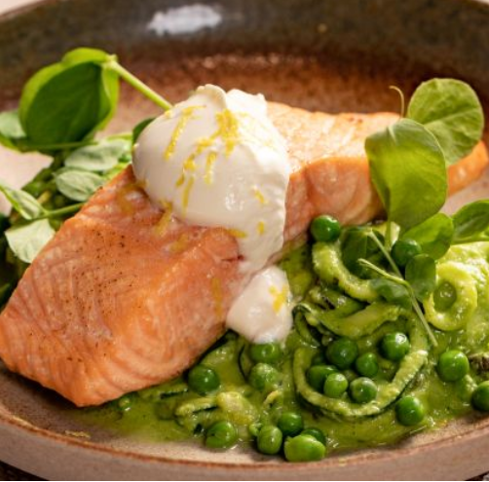
Roast Salmon Fillet with Lemon & Pea Courgetti
Serves: 4, 444 Kcal

- 4 x 120g salmon Fillets
- 4 Courgettes, spiralized
- 300 ml of 0% Greek Fat Yogurt
- Teaspoon of rapeseed oil
- 1 long shallot, finely sliced
- 500g frozen peas, defrosted
- 75ml reduced salt vegetable stock
- Zest of one lemon
- Juice of half a lemon
- Pepper, for seasoning
- Handful of peashoots, for garnish

- Preheat the oven to 200 degrees.
- Heat half of the oil in a small non-stick pan and cook the shallot for a few minutes until softened. Add 400g of the peas (reserving the rest for later) and stock, and simmer for 3 - 4 minutes until the peas are tender, and most of the liquid has evaporated. Use a stick blender or liquidiser to whizz to a smooth purée. Season with pepper and add the lemon juice to taste. Return to the pan and keep warm over a very low heat.
- Place the salmon on a baking sheet, brush with a small amount of rapeseed oil and season with pepper. Roast for 10-12 minutes.
- In a microwave safe bowl, microwave the courgetti on full power for 1 minute. Tip the courgetti onto some kitchen paper, blot off the excess moisture and leave to drain for a few minutes. Mix the courgetti with the pea and lemon puree and add the remaining peas.
- Mix the 0% Greek fat yogurt with the lemon zest and season with pepper.
- To serve, divide the courgetti and pea puree between the plates and place a salmon fillet on top. Add a spoonful of the 0% Greek fat yogurt mix and garnish with the peashoots

https://www.heartuk.org.uk/tasty-recipes/recipe-detail/226-roast-salmon-fillet-with-lemon-pea-courgetti

