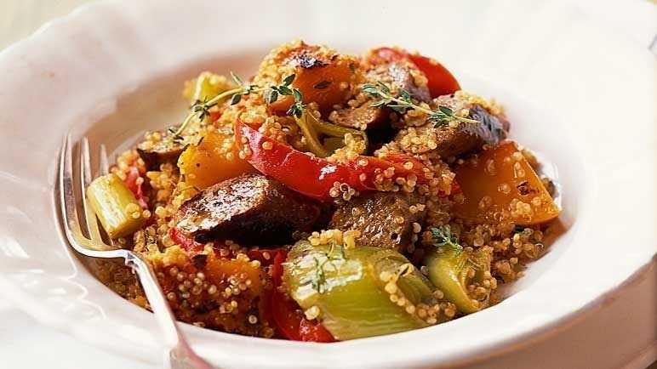
Vegetarian sausage, butternut and red pepper stew (V)
Serves 4, 458kcal, 9.6g fibre,
- 2 tbsp olive oil
- 375g vegetarian sausages
- 1 small butternut squash, peeled, deseeded and diced
- 2 red peppers, deseeded and cut into strips
- 4 leeks, trimmed and cut into 2cm pieces
- 6g thyme, stalks removed
- ½ tsp smoked paprika
- 200g quinoa
- 750ml vegetable stock, made with 1½ stock cubes

- Heat a large frying pan with 1 tbsp oil and cook the sausages for 5-6 minutes. Transfer to a board, cut into 2cm chunks and set aside.
- Heat the remaining oil, then add the butternut squash and cook for 10 minutes, stirring occasionally until brown.
- Add the peppers and leeks. Cook for 2-3 minutes, stirring to coat well, then add the sausages along with the thyme, paprika, quinoa and stock.
- Cover and cook for 15 minutes until everything is tender. Serve.

https://www.sainsburys.co.uk/gol-ui/recipes/vegetarian-sausage-butternut-and-red-pepper-stew

