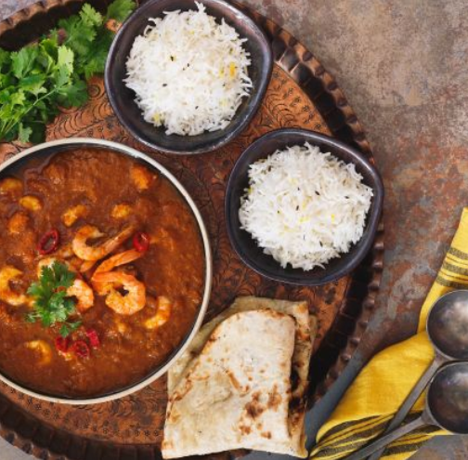
Prawn and Vegetable Curry
Serves: 4, 416 Kcals
- 4 cloves garlic
- 1 onion
- 1 tbsp olive oil
- 1 apple, grated
- 2½ tbsp curry powder
- 1 tsp garam masala
- ½ tsp turmeric
- 400g chopped tomatoes, tinned
- ½ red chilli, chopped finely
- 200ml boiling water
- 2 tsp sweetener
- 110g (7 tbsp) tinned chickpeas, drained and rinsed
- 200g frozen prawns
- 50ml soya milk
- Coriander leaves to garnish

- 265g basmati rice / 1 ½ cups
- 400ml boiled water

- Measure and pour out the basmati rice, cover with the boiled water and cook according to packet instructions.
- Cook the garlic and onion in olive oil over a medium heat until golden. Add the curry powder, garam masala and turmeric and cook for a further minute. Add in the grated apple, chopped tomatoes and red chilli and stir to combine then add 200ml of water and stir again. Bring up to the simmer and cook for a further 2 minutes.
- Add the chickpeas and frozen prawns and cook until they soften and are hot all the way through. Once hot, stir in the sweetener and soya milk.
- Serve the rice and curry in a bowl and garnish with coriander leaves.

https://www.heartuk.org.uk/tasty-recipes/recipe-detail/84-prawn-and-vegetable-curry

