Low-fat creamy tuna pasta
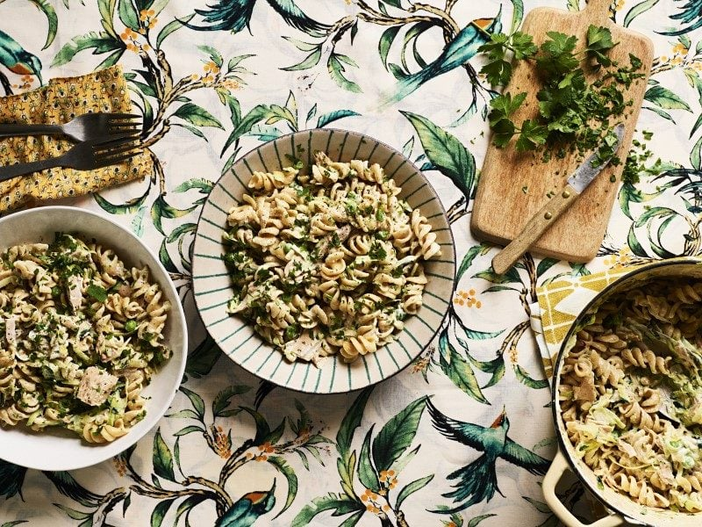
Serves: 2 606kcal, Fibre 14.6g
- 1 tbsp olive oil
- 1 onion, finely chopped
- 200g (7oz) wholewheat pasta (such as fusilli)
- 75g (3oz) frozen peas
- 3 cloves garlic
- 1 tsp dried mixed herbs
- 150ml (5fl oz) low-fat cream cheese
- 145g (5oz) can tuna in water, drained
- 1 courgette, coarsely grated
- Finely grated zest and juice of ½ lemon
- 2 tbsp fresh parsley, chopped

- Heat the oil in a medium pan and cook the onion over a low heat for 10-15 minutes, stirring occasionally until softened but not browned. It’s important to cook the onion until really softened to get maximum flavour.
- While the onions are softening in the pan, cook the pasta in boiling water for 10-12 minutes, adding 1 whole clove of garlic, ½ tsp dried herbs and plenty of black pepper to the water. Add the peas for the last 2 minutes of cooking time. Drain the pasta and peas.
- By this point, the onions in the pan should have softened. Crush and add the remaining 2 cloves of garlic to the onions and fry for another minute. Then stir in the low-fat cream cheese and the tuna.
- Combine the creamy tuna sauce with the drained pasta and peas. Mix in the grated courgette, lemon zest and juice. Serve sprinkled with the parsley.

https://www.bhf.org.uk/informationsupport/support/healthy-living/healthy-eating/recipe-finder/low-fat-creamy-tuna-pasta

