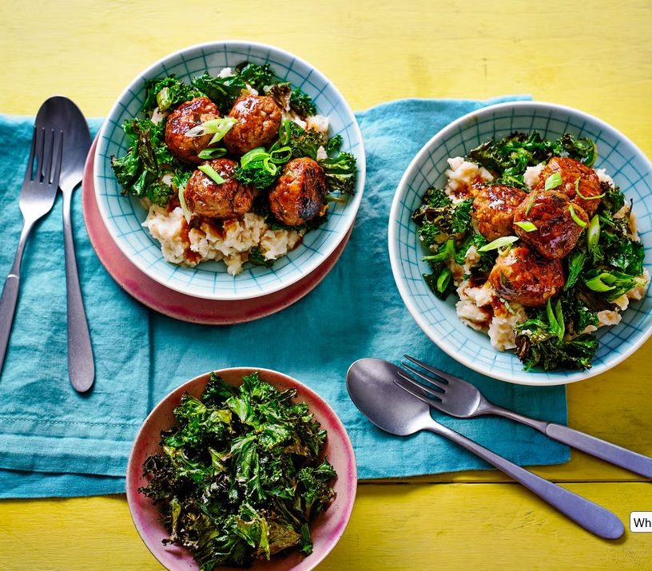
Juicy pork meatballs with a butter bean mash
Serves 4, Kcals 410, Fibre: 13g

For The Meatballs
- 4 spring onions, finely chopped
- 2 garlic cloves, crushed
- 1 piece fresh root ginger, peeled and grated (about 2cm)
- 2 Tbsp. white miso paste
- 400 g lean pork mince
- 2 tsp. vegetable oil
- 2 Tbsp. soy sauce
- 1 Tbsp. runny honey
For The Mash
- 3 x 400g tins butterbeans, drained and rinsed
- Juice 1/2 lemon
For The Kale
- 150 g bag sliced kale, woody stems removed
- 2 tsp. oil

- Preheat oven to 180°C (160°C fan) mark 4. For the meatballs, mix most of the spring onion (reserving some for garnish), garlic, ginger, miso paste and pork in a bowl with some seasoning. Shape into 16 balls and place on a baking tray lined with baking parchment.
- Next, mix the kale in a bowl with the 2tsp oil, then spread on to a baking tray and cook in oven for 10min, until crisp and lightly golden.
- Meanwhile, heat meatball oil in a large frying pan over medium-high heat. Fry meatballs for 10-15min, turning frequently, until golden and just cooked through. Add soy, honey and 2tbsp water and bubble for 2min, until meatballs are coated in the sticky glaze.
- Meanwhile, make mash. Bring 300ml water to the boil in a large pan and add the beans. Simmer for 5min, then mash with a potato masher. Mix in lemon juice and plenty of seasoning. Loosen with some just-boiled water, if needed.
- To serve, divide the mash between 4 bowls and top with the kale. Lay on the meatballs, drizzle over any remaining pan sauce and scatter over the remaining spring onions.

https://www.goodhousekeeping.com/uk/food/recipes/a35380231/miso-pork-meatballs-with-kale-crisps-and-butter-bean-mash/

