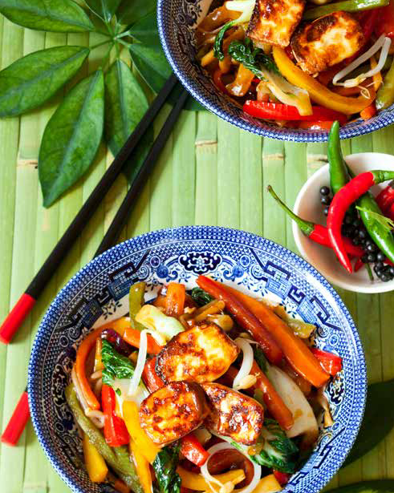
Stir fried chicken and vegetables
Serves 4 420 kcals, Fibre 3g

- 2 tbsp sesame or peanut oil
- 720g chicken breast cut into 2cm chunks
- 1 onion, quartered, separate out all the
- layers
- 1 clove of garlic, finely chopped or crushed
- 2cm x 2cm piece of fresh ginger cut into matchstick or 2 tsp minced ginger
- 1 small red chili, de-seeded and finely chopped
- 1 red capsicum cut into long strips
- 1 carrot cut into long strips
- 200g of sugar snap peas
- 1 bunch of baby bok choy
- 2 tbsp salt reduced soy sauce
- ½ cup dry sherry or Chinese rice wine
- 1 lime cut into wedges to serve
- 4 tsp sesame seeds to serve

1. Heat 1 tbsp of oil in a large wok, add the chicken and toss until just golden. Remove from the wok and set aside.
2. Heat the remaining oil in the wok and add the onion, garlic, ginger and chili and toss for 2-3 minutes.
3. Add the capsicum and carrot and continue to toss another 2-3 minutes.
4. Add the sugar snap peas and keep tossing, then add the chicken back into the wok and continue to toss.
5. Combine the soy sauce and Chinese rice wine and add to the wok, continuing to toss.
6. Add the Bok choy and toss until it’s just wilted. Remove the wok from the heat and immediately serve into 4 bowls.
7. Sprinkle each bowl with sesame seeds and serve with a wedge of lime. Enjoy!

https://www.hriuk.org/health/recipes

